A Guide to Bimbi Preschool
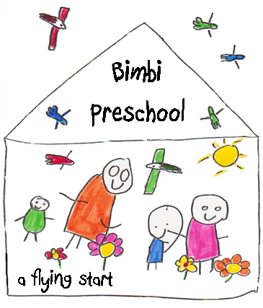

Bimbi Preschool - Red Hill Public School
Parkhurst Street WAGGA WAGGA
02 6931 1263
Table of Contents

Welcome 3

Philosophy 4

Our Curriculum 6

Daily Routine 8

Important things to know 9

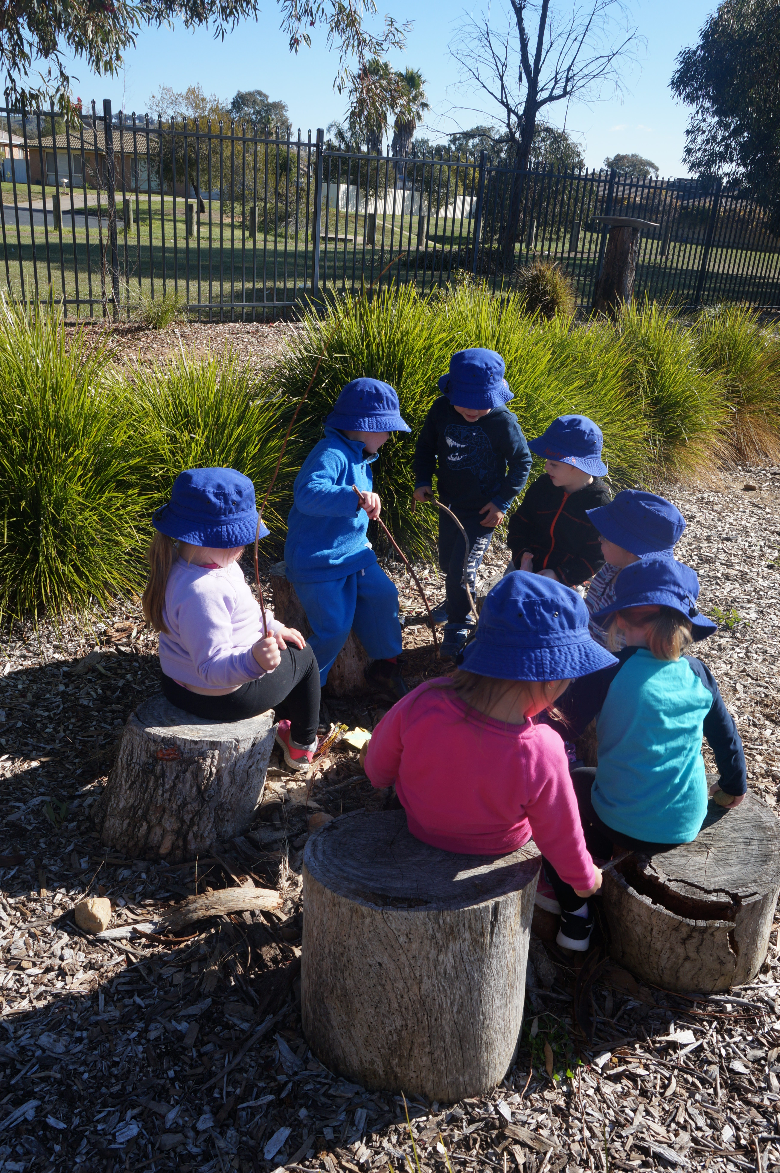

Welcome

Bimbi Preschool is a part of Red Hill Public School and is open to children turning 4 before 31st July, the year before they attend Kindergarten at Red Hill Public School.
There are currently 2 sessions – Monday and Tuesday or Thursday and Friday, with an alternating Wednesday.
Bimbi Preschool is the only Department of Education Preschool in Wagga Wagga which places us with the unique ability to support the children of Bimbi to achieve a smooth transition to Red Hill Public School, as they are already a part of the vibrant and positive school community at Red Hill Public.
Bimbi Preschool embraces the Early Years Learning Framework as a part of the National Quality Framework. At Bimbi we believe children learn best through well planned and supported play, based on the interests and emerging skills of the children. Bimbi children learn in our well-resourced classroom and our large creative outdoor garden. Experienced and qualified Early Childhood Professionals deliver our innovative preschool program.

National Quality Standard Assessment and Rating
Bimbi has been acknowledged for its achievements in Exceeding the National Quality Standards and striving for quality outcomes for children. In particular, collaborative partnerships with families, communities and support agencies and leadership and service management demonstrates the commitment to quality by the approved provider, educators and staff.

Overall Rating: Exceeding National Quality Standards (E)
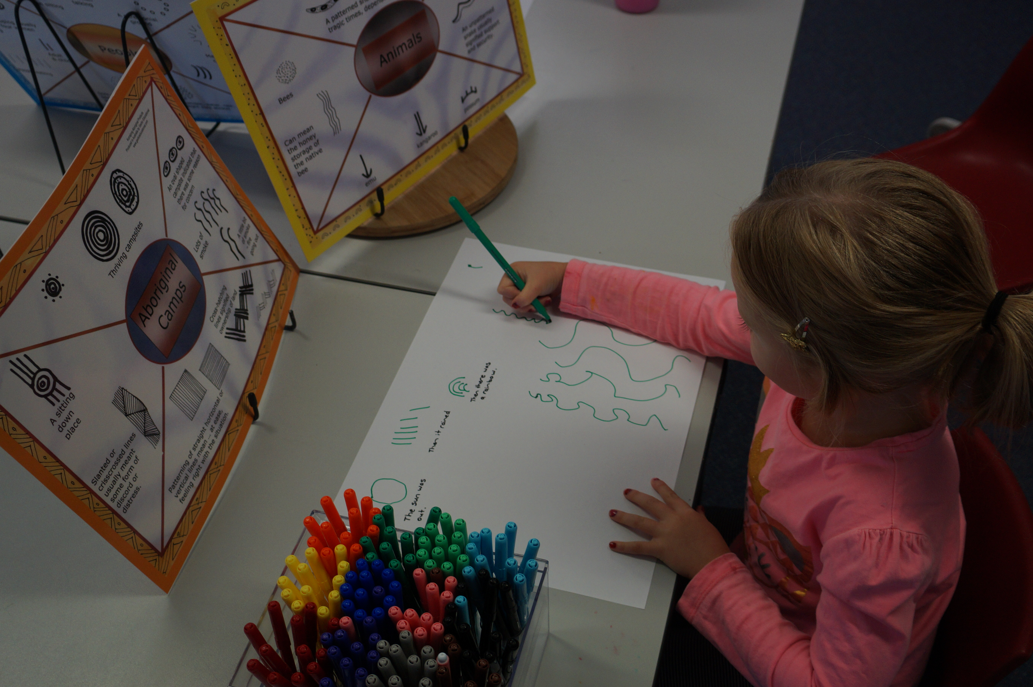

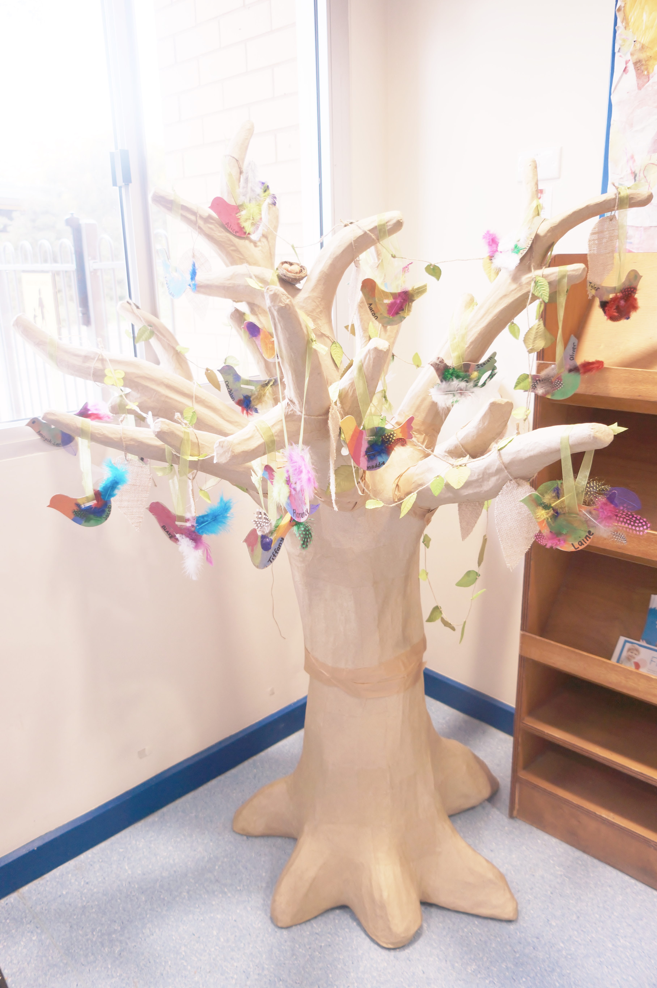
At Bimbi we view children as:

- Independent
- Capable
- Resourceful
- Unique
- Interested
- Confident
- Playful
- Creative
- Social and friendly
- Willing to contribute
- Having their own voices and ideas
Our preschool program reflects this through:
- Free and open play
- Interest based learning
- Valuing learning through play
- A flexible and inclusive program, responsive to the children’s needs
- Discovery, problem solving, creativity, exploration and investigation
We value:
- A warm, friendly and welcoming environment
- Natural play spaces that children can connect with, and feel comfortable in
- Responsive and respectful relationships with children, families and the community
- The rich backgrounds and diversity which children and families bring with them
- Learning through meaningful experiences
- The knowledge children, families and the community bring to the preschool, recognising everyone as an educator in children’s lives.
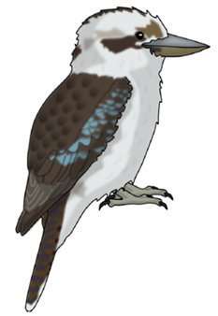
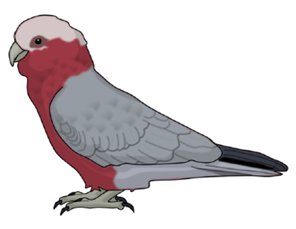

We acknowledge the Wiradjuri people and recognise the strength, resilience and capacity of Aboriginal People in our community.

We are proud of our preschool name – Bimbi. Which is a Wiradjuri word meaning ‘birds’. Our two preschool groups have been named after birds that often visit our garden, using the Wiradjuri words.
Gugubuarra’s (Kookaburra)
Gilaa’s (Galah)
Each day we acknowledge the presence of Wiradjuri people past and present and the land on which our preschool is on by singing our ‘Welcome to Country’ song with Jess leading the children (Appendix C). We also ask the children what they would like to acknowledge each morning after singing the song.
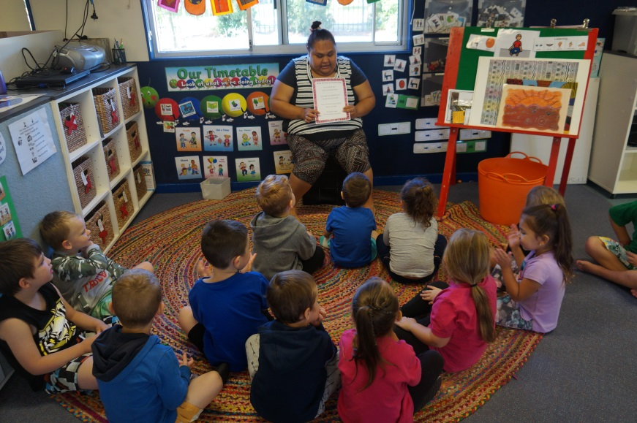

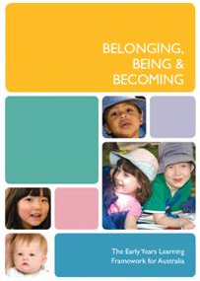
Preschool Outcomes

At Bimbi Preschool we follow the Early Years Learning Framework – ‘Being, Belonging and Becoming’

Across the year the preschool program works towards each child achieving the following outcomes:

- Children have a strong sense of identity.
- Children are connected with and contribute to their world.
- Children have a strong sense of wellbeing.
- Children are confident and involved learners.
- Children are effective communicators.

We aim to achieve these outcomes through the following principles and practices:

Principles:
- Secure, respectful and reciprocal relationships
- Partnerships
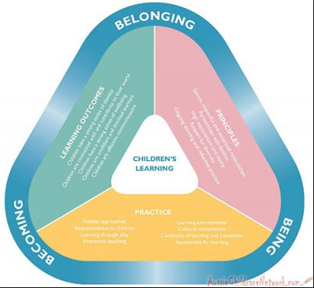
- High expectations and equity
- Respect for diversity
- Ongoing learning and reflective practice

Practices:
- Holistic approaches
- Responsiveness to children
- Learning through play
- Intentional teaching
- Learning environments
- Cultural competence
- Continuity of learning and transitions
- Assessment for learning

If you would like to see the curriculum framework or have any questions please ask an educator.

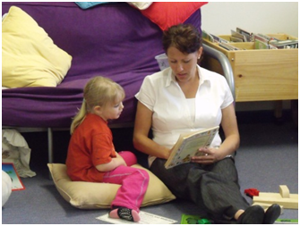
Development of these key components offers the very best start for your child at Bimbi Preschool.

Service Approval Number: SE-00011500 Assessment and Ratings ID: ASR-00010407

Red Hill Public School Preschool

has achieved the following ratings:
Quality Area 1 | Educational program and practice  RATING: Exceeding National Quality Standard (E)
Quality Area 2 | Children’s health and safety  RATING: Exceeding National Quality Standard (E)
Quality Area 3 | Physical environment  RATING: Meeting National Quality Standard (M)
Quality Area 4 | Staffing arrangements  RATING: Meeting National Quality Standard (M)
Quality Area 5 | Relationships with children  RATING: Meeting National Quality Standard (M)
Quality Area 6 | Collaborative partnerships with families and communities RATING: Exceeding National Quality Standard (E)
Quality Area 7 | Leadership and service management  RATING: Exceeding National Quality Standard (E)
The overall rating for a service is determined by the combination of the Quality Area ratings achieved.
If a service is rated below the National Quality Standard in any Quality Area, the overall rating will reflect the lowest Quality Area rating. To achieve an overall rating of Exceeding National Quality Standard, a service needs to achieve Exceeding National Quality Standard in four or more Quality Areas of which two must be from Quality Area 1, Quality Area 5, Quality Area 6 or Quality Area 7.

This service is rated overall at
Exceeding National Quality Standard (E)
NSW Department of Education and Communities Date of issue: 29 June 2020
This service has been assessed against the National Quality Standard for Early Childhood Education and Care and School Age Care
and these ratings have been awarded in accordance with the Education and Care Services National Law Act 2010
and the Education and Care Services National Regulations 2011

Bimbi Preschool Daily Routine
9.00 | Arrival  Learning through play  Fruito
10.45 | Pack away – transition to group time
11.00 | Yarning Circle  Group time  Language and Literacy focus
11.30 | Hand washing – transition to lunch
11.40 | Lunch
12.15 | Learning through play
1.45 | Pack away – transition to group time
2.00 | Group time  Music / movement / numeracy focus
2.25 | Hand washing – transition to afternoon tea
2.30 | Afternoon Tea
2.50 | Pack away & prepare for home
3.00 | Preschool closed
The Preschool routine outline’s the general flow of the day, which is generally consistent to support the children’s familiarity and sense of security. However it is flexible to ensure we are responsive to the needs of the children and are able to follow or extend the children’s interests.

What to bring to preschool:

Healthy lunch and afternoon tea
Piece of fruit
Water bottle
Change of clothes

Apply sunscreen before coming to preschool
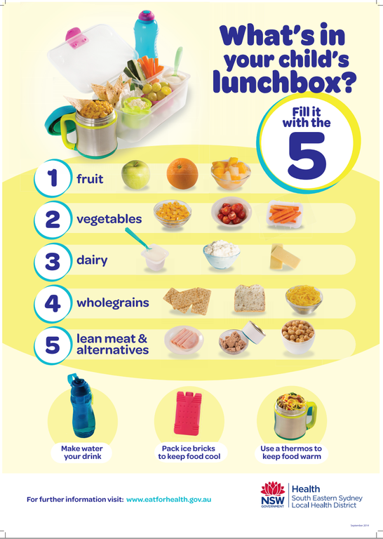

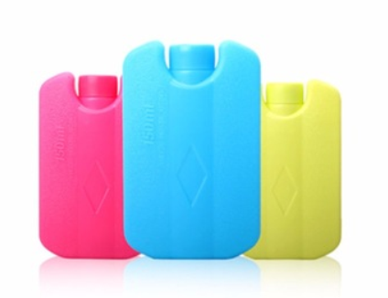
We are unable to store lunch boxes or any of the children’s food in the refrigerator. Please pack your child’s lunch box with an ice pack to keep it cool.

We are not able to cook or reheat food, this includes tinned food. Food will not be warmed, reheated or prepared by an Educator.

Food that is not allowed
- Nut or nut products (peanut butter, Nutella spread etc.)
- Lollies – or items that look like lollies
- Roll ups and fruit strings / lollies
- Chocolate or chocolate biscuits
- Cakes / cupcakes
- Cordial / juice / fruit box – water only in water bottles
- Flavoured milk – water only

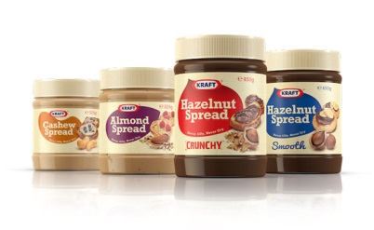
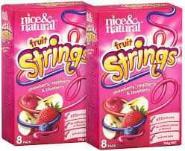

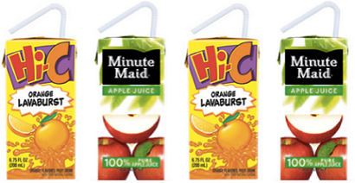
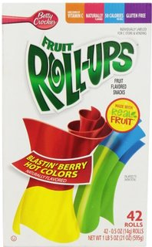

If your child brings any of these food items they cannot be consumed at preschool and the food items will be sent home.

If it is a special occasion please talk to an educator about bringing in a cake or sometimes food.

Arrival and Departure routine:

Preschool opens at 9.00am
Parent sign in
Put your:
* Bag in locker
* Water bottle on bench
* Piece of fruit in fruit bowl
Help your child to sign in at the children’s sign in table
Settle your child into play and make sure you say goodbye. If your child is having difficulties settling into play our educators can support you.

Pick up time is 2.30pm-3.00pm - Preschool closes at 3.00pm
The children can be collected from preschool at any time that is convenient for you. For safety reasons the side gate into the preschool is unlocked at 2.30pm to allow time for children to be collected before preschool closes at 3.00pm. If you need to access the preschool earlier please enter through the school from Hawkes Place.

Children are not permitted on the premises outside of our opening hours (9.00am-3.00pm). If you cannot collect your child by 3.00pm please make alternative arrangements prior to 3.00pm and call the preschool to inform of who will be collecting your child. Educators will only release your child to people on your authority to collect list.

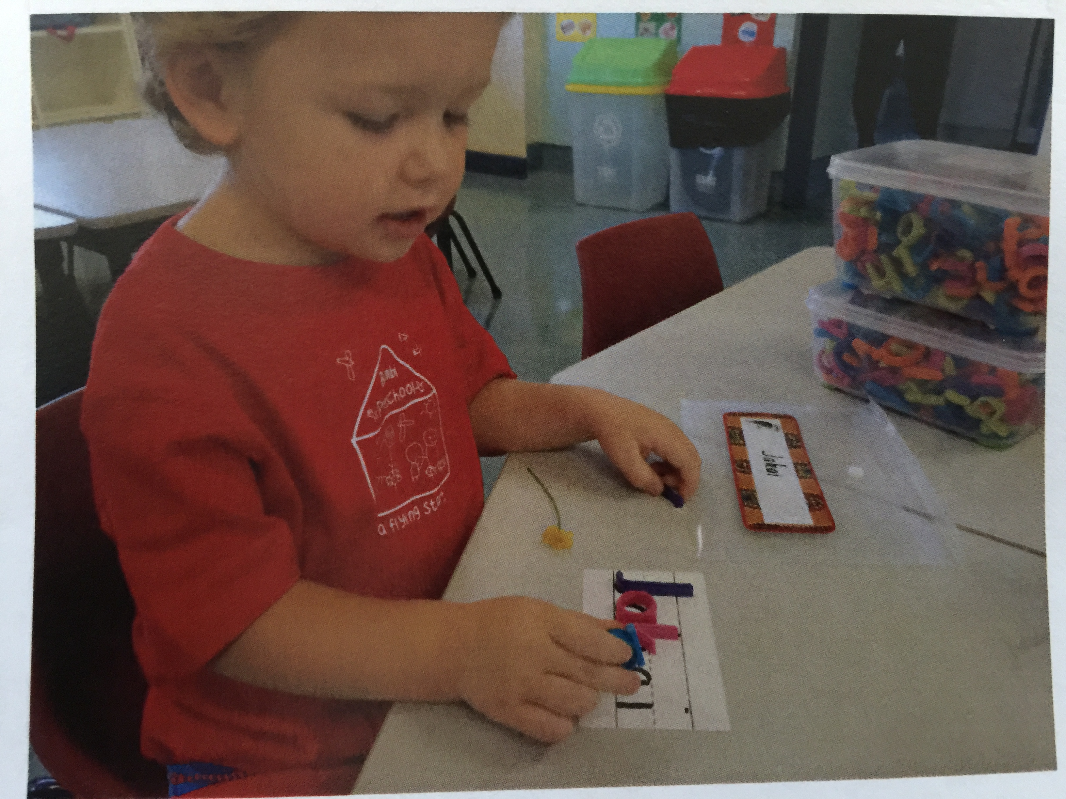

Other information

Please apply sunscreen to your child before coming to preschool

Clothing
Please send your child in comfortable clothing that is OK to get dirty. Please also pack a change of clothes, even if your child is fully toilet trained as we often have water or messy play which may require a change of clothes. No singlet tops are allowed due to our Sun Safety Policy.

Bimbi t-shirts are available from the school office for $15.00.

All children are provided with a school hat at the beginning of the school year.

Fees
You will be given an invoice at the start of each term for the whole terms fees. Fees are charged for the whole term, no discounts are applied for non-attendance. These are to be paid at the school office. The office staff can help you with payment plans if required.

Our Natural Environment
We are proud of our beautiful garden and recognise the importance of children experiencing natural environments. Our garden is home to a variety of bugs and insects such as witchetty grubs, ants, mosquitoes, bees and more. All care is taken to prevent insect bites and stings however it is a risk to be considered when enrolling at Bimbi.

Complaints / Compliments & Suggestions
If you have any of these please speak to one of our educators or if you prefer we have a book located in the preschool foyer. This book also has a copy of the Department of Education complaints policy. Formal complaints can be directed to the School Principal – Mr Matthew Gray.

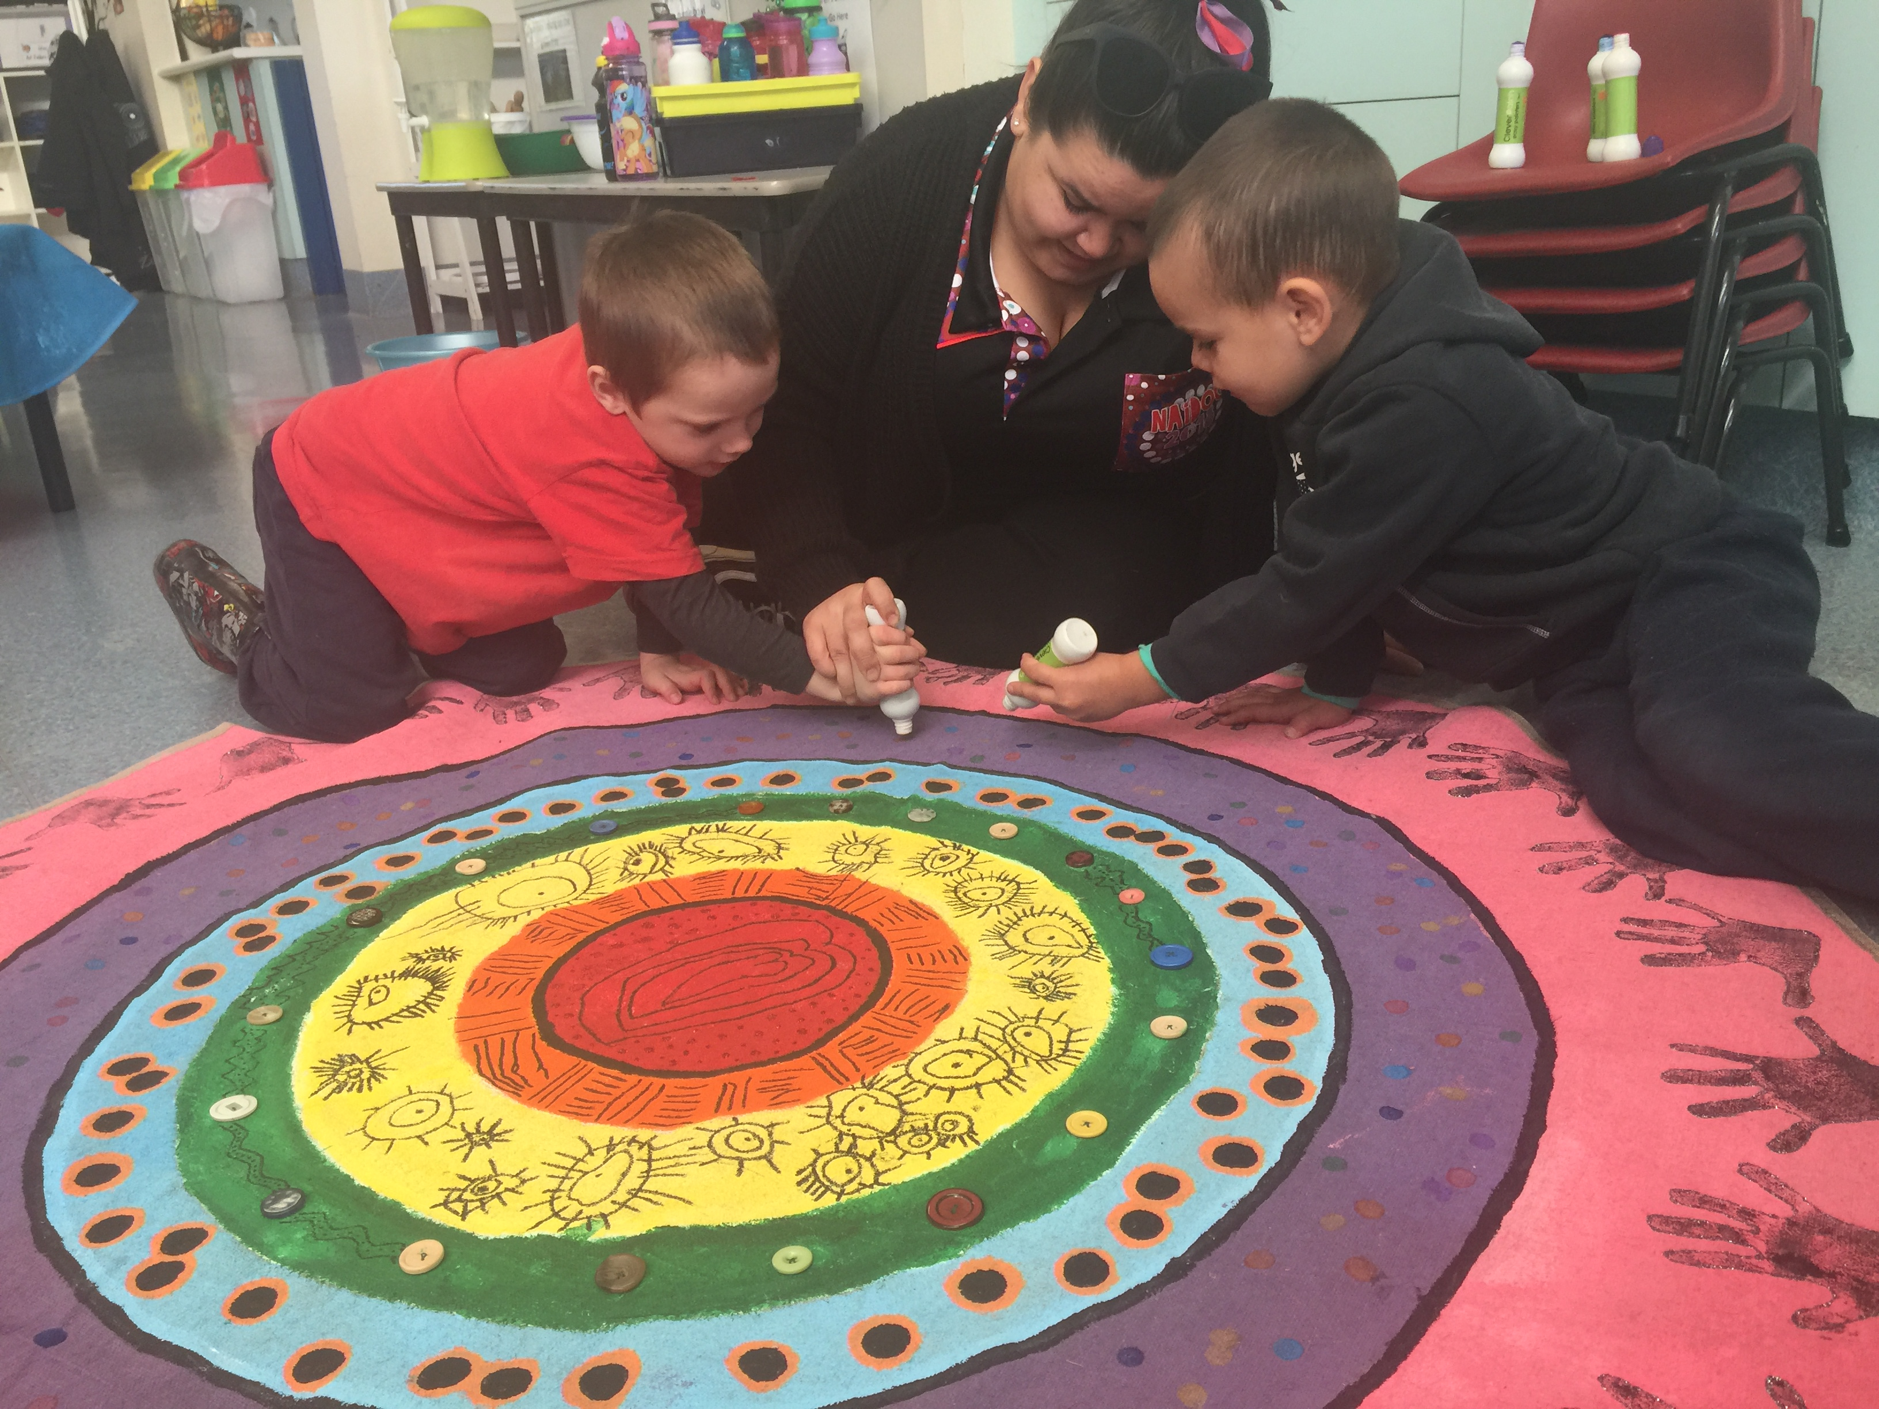

Toys from home
Please do not bring toys from home. We are well resourced with a wide range of educational toys for the children to explore. To ensure your toys are not lost or broken please leave them at home.

Medical Conditions
Please inform the Educators if your child has or develops a medical condition (such as asthma, anaphylaxis, epilepsy etc). We will work with you to develop a communication and action plan to ensure your child’s health and safety.

Policies and Procedures
Bimbi Preschool has a folder with our localised procedures based on the NSW Department of Education Policies. The folder is available for you to read at any time. The Department of Education policies are available on their website – www.education.nsw.gov.au

Quality Improvement Plan (QIP)
Each year the Bimbi Educators complete a QIP to self-assess our performance in delivering quality education and care and to plan future improvements. A copy of this is available in the preschool foyer. Any input or comments are appreciated.

Kinderloop
We use Kinderloop as a communication tool with families and also to document the children’s learning. Upon enrolment to Bimbi you will receive an email invitation to join our closed group. There is also an app which is a free download for ease of access.

